**Hardware**

**MATCHING**

This illustration represents the major hardware components of a computer. Several components have already been identified for you.

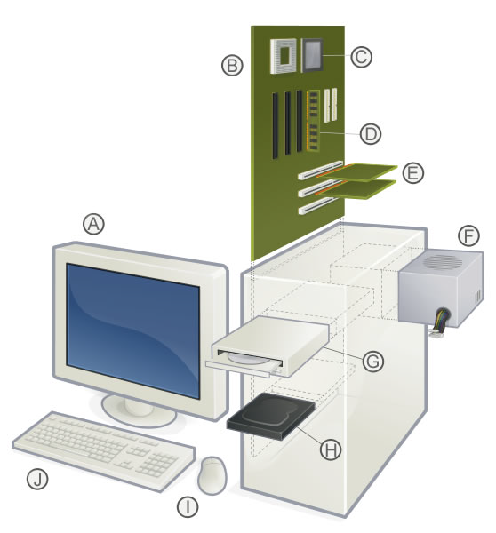

|  |  |  |  |
| --- | --- | --- | --- |
| A) | ? | F) | Power Supply Unit |
| B) | Motherboard | G) | ? |
| C) | ? | H) | ? |
| D) | Main Memory (RAM) | I) | ? |
| E) | Expansion Cards | J) | ? |

1) Which component is the Hard Disk Drive?

2) Which component is the Keyboard?

3) Which component is the Microprocessor?

4) Which component is the Monitor?

5) Which component is the Mouse?

6) Which component is the Optical Disk Drive for CDs and DVDs?

7) Which component is the Main Memory (RAM)?

8) Which component is the Motherboard?

9) Which component is the Expansion Slot?

10) Which component is the Power Supply?